# CERTIFICATE FROM THE SUPERVISOR

This is to certify that the summer project entitled “Result Management System” is an academic work done by **Sajal Maharjan** submitted in partial fulfillment of the requirements for the degree of Bachelor of Information Management at Faculty of Management, Tribhuvan University under my guidance and supervision. To the best of my knowledge, the information presented by him in the summer project report has not been submitted earlier.

______________________

Signature of the Supervisor

Name: Mr. Chakra Rawal

Date: Sept 15 2021

**ASIAN SCHOOL**

**OF MANAGEMENT & TECHNOLOGY**

Affiliated to Tribhuvan University

Gongabu-4, Kathmandu

Date: Sept 15 2021

**LETTER OF APPROVAL**

We, the evaluation committee of the Summer Project report have approved that Summer Project entitled “**Result Management System**” submitted by “**Sajal Maharjan**” is fully adequate and satisfactory in scope and quality for the partial fulfilment of Bachelor of Information (BIM), Faculty of Management.

Evaluation Committee

………………

Mr. Chakra Narayan Rawal

Supervisor

………………

Mr. Surya Bam

Program Coordiator

………………

External Examiner

………………

Internal Examiner

………………..

Er. Anil Lal Amatya

Principal

# STUDENT DECLARATION

This is to certify that I have completed the Summer Project entitled “Result Management System” under the guidance of “Mr. Chakra Rawal” in partial fulfillment of the requirements for the degree of Bachelor of Information Management at Faculty of Management, Tribhuvan University. This is my original work and I have not submitted it earlier elsewhere.

Date:

__________________

Signature of Student

Name: Sajal Maharjan

# ACKNOWLEDGEMENT

This project is prepared in partial fulfillment of the requirement for the degree of Bachelor in Information Management (BIM). As conceptual knowledge is not enough for successful practice in Information Technology, it is necessary to gain more knowledge and experience through real-world projects. I would like to extend my appreciation to Tribhuvan University and the Asian School of Management and Technology for providing us the opportunity to create a real-world project based on an organization operating in a real-world environment.

The satisfaction and success of completion of this task would be incomplete without heartfelt thanks to people whose constant guidance, support, and encouragement made this work successful. On doing this undergraduate project I have been fortunate to have help, support, and encouragement from many people we would like to acknowledge them for their cooperation.

I would also like to extend my heartfelt thanks to Mr. Chakra Narayan Rawal, for the guidance he has to provide in the process of preparing this project, without whom this project never would have been completed.

At last, I would like to thank my peer and colleagues who have helped me throughout the development of this project through discussions of ideas, sharing their knowledge, and giving their opinion about things that put me in a dilemma.

# EXECUTIVE SUMMARY

The report herein includes all the activities done during the summer project on the topic of "Result Management System". The project is complete as a part of the requirement of the Bachelor of Information Management course syllabus at Tribhuvan University.

The ‘Result Management System’ system is designed to replace the traditional way of record-keeping in the business site with a new digitized and more efficient way. Previously, at the project site, all the student record keeping was done traditionally, which resulted in low efficiency while searching for the data and loss of time and a time-consuming process to find the required data. This system developed helps the user to store all the student records of the school in one digital place. It helps to track all the student records in one place securely. The process to retrieve a needed record at the required time is also very easy with this system. School staff can quickly find a needed record using the search and advanced search function provided by the system. School staff can associate and attach an image of each student to further store more information about the record in the system.

All in all, this system developed will help the user in making the record-keeping system much more efficient and easier and make the information retrieval process quick and convenient. This system is expected to save time and eliminate the need for redundant work for the staff members of the school, within mind to implement the system without using extra manpower, but through the everyday available device, a smartphone.

Contents

CERTIFICATE FROM THE SUPERVISOR 1

STUDENT DECLARATION i

ACKNOWLEDGEMENT ii

EXECUTIVE SUMMARY iii

List of Figures 3

List of Tables 3

CHAPTER 1: INTRODUCTION 1

1.1 Background 1

1.2 Introduction of the organization 1

1.3 Current situation of the organization 2

1.4 Problem Identification 2

1.5 Objectives 2

1.6 Methodology 2

1.6.1 Data and Information 2

1.6.2 Project Framework 3

1.6.3 Tools Used 4

CHAPTER 2: TASK AND ACTIVITIES PERFORMED 7

2.1 Analysis of tasks, activities, problems and issues 7

2.2 Feasibility Study 7

2.2.1 Technical Feasibility 7

2.2.2 Economic Feasibility 8

2.2.3 Operational Feasibility 8

2.3 Requirement Analysis 8

2.3.1 Functional Requirements 8

2.3.2 Non-functional requirements 9

2.4 Solution Design 10

2.4.1 Use Case Diagram 10

2.4.4 Activity Diagram 11

2.4.5 Work Flow Diagram 12

2.5 Implementation 13

2.5.1 The User module 13

2.5.2 The Admin module 14

2.6 System Testing and Validation 17

2.6.1 System Testing 17

2.6.2 Integration Testing 17

2.6.3 Validation Testing 17

2.6.3 Unit Testing 18

2.7 Findings 19

CHAPTER 3: DISCUSSIONS AND CONCLUSION 20

3.1 Discussion 20

3.2 Conclusion 20

3.3 Further Enhancement 20

BIBILIOGRAPHY 21

APPENDICES 22

Interview Questions 22

# List of Figures

Figure 1.1: Project Framework 03

Figure 2.1: Project Use Case Diagram 10

Figure 2.2: Project Activity Diagram……………………………………………………………….11

Figure 2.3: Project Activity Diagram ……………………………………………………………….12

Figure 2.4: Home Page……………………………………………………………………………...13

Figure 2.5: Search Record Page…..………………………………………………………………...14

Figure 2.6: Dashboard Page...………………………………………………………………………14

Figure 2.7: Adding of Record Page ……………………………………..…………………………15

Figure 2.8: View Result Page …………………………………………………….………..………16

Figure 2.9: Setting…………………………………………………………...……………………...16

# List of Tables

Figure 2.10: Test Cases………………………………………………………......…………………19

# CHAPTER 1: INTRODUCTION

## Background

Summer Project report is an essential requirement for graduation from the Faculty of Management, Tribhuvan University. This assignment is an off-the classroom and field-based study project. It allows students to reflect and integrate their learning over their five semesters of study, and create innovative and original work in an area of their interest related to any area of business administration/Information Technology. The main vision of the summer project is that through the assignment students can gain a new perspective into the real world and it is also an excellent networking platform for students to get acquainted with people from different organizations, business backgrounds, skills, expertise, etc. This project is about replacing the traditional manual record-keeping system with the new digitized way of record keeping. This system is focused on recording the information of the organization like expenses and incomes to prevent duplication of work and provide systematic management of the business funds. In the context of Nepal, generally, institutions or organizations are using printed and digital media marketing. And in the present scenario managing data and information about the user in a digitized and automatic manner is a prime concern of all organizations.

## Introduction of the organization

“Prime English Secondary School” is a private school located at Naikap, Kathmandu, established in 2055 BS. It has been providing schooling and teaching services to many students at an affordable fee. It provides teaching services from grade kindergarten (Pre-School) up to class 10. It supplies products to households, organizations as well as automobile owners. The school also provides extracurricular activities such as a yearly visit to different places, dance classes, music glasses, many indoor and outdoor activities, etc.

For this project, the idea of an online result management system for the school was chosen. As the school doesn’t offer any online services for the result, the option of the online result was considered. The system proposed in this paper works with phones or desktops/laptops and can work without any extra hardware. This also allows us to not be restricted by hardware and allows the system to work with the presence of common devices that are normally available to all.

## Current situation of the organization

At present, Prime English Secondary School has been performing all its record keeping of its students results in one place offline that is not safe. The day-to-day expenses, sales incomes and other incomes are being recorded manually on a paper till date. The important receipts and bills are being hole punched on a nail. This method has proven to be very ineffective. The process of manually recording on a paper is hard and tedious. The chances of losing valuable information is very high as papers can be torn, damaged or lost. Some digits or numbers on the paper are lost or distorted as a result of hole punching them. This has resulted in misrepresentation of actual data. There have been many incidents where the business had to face loss because a sales record was lost or not recorded. Finance tracker aims to be the solution for this.

## Problem Identification

The organization is still implementing manual and traditional way of record keeping despite today’s day and age. This needs to be changed to be updated with the current environment. A business should always be updated and keep up with the environment in which it is functioning. The process of manually recording on a paper is hard and tedious. And later all those records have to be printed and distributed individually to the students. As in the present condition online result system is better due to the current pandemic situation.

## Objectives

The main objective of this project is to develop a system that will digitize the overall result record keeping process of the organization/schools. Some objectives of the system are:

* To record the results of the students in a systematic and effect way
* To record the results of the students according to their grades
* To be able to retrieve the needed record quickly and on time to facilitate data availability.

## Methodology

There are various methodologies to gather the required data and information. For the project, various methods are used to extract the information required for the proposed system as follows:

### 1.6.1 Data and Information

For the completion of the project, data were collected from different sources. These data were very much helpful for the completion of the project. Following are the major sources from where the data were obtained:

#### Publication Research

For preparing this report many online news articles, journals and other related websites and apps related to record keeping system were reviewed.

#### Direct Interview

This research is based on interview taken at Prime English School. A direct personal interview with Mr. Bal Krishna Betwal, principal of Prime English Secondary School was taken to gather more information on their daily operations and on the methods and features required in the Result Management System.

#### Work Process Observation

I have closely observed the work process of the organization related to developing a Result Management System. It gave me many ideas about how can manual system be converted into digital system and what components must the system have.

### Project Framework

Project framework is a combination of processes, tasks, and tools used to transition a project from start to finish. This chapter reveals the proposed method of implementing the project. The important on this is systematic planning and implementation in order to complete system on time.

Figure 1.1: Project Framework

Project

Initiation

Project

Planning

Project

Closure

Project

Execution

Project

Control

Project

Monitoring

* **Project Initiation:** This is the first phase. In this phase first of all the organization was selected, different information about the objective, scope and feasibility of the project was collected. As per the information provided by the concerned person. For further details, the organization was visited. After the approval of the proposal defense, the next phase was started.
* **Project Planning:** In this phase planning was done for how to manage the timeframe within which the project should be finished. Division of the time and work in different modules was done in different categories such as front end, back end, data collection, organization visit etc.
* **Project Execution:** In this phase, I prepared interview questions related with the concerned topic and presented them to the owner of the organization for his response. It helped to know about the working scenario and activities performed by the organization. The details were recorded thoroughly. System development begins in this phase. The project execution phase is usually the longest phase in the project life cycle and it typically consumes the most energy, time and the most resources.
* **Project Control:** After collecting all information and data about the organization. The adjustment was done to the organization.
* **Project Monitoring:** Project monitoring was done by checking the project in timely manner.
* **Project Closure:** The project closure phase is the last phase in the project life cycle. In this phase, we prepare reports of overall project and activities. Project Closure involves handing over the deliverables and passing the documentation including all the activities from the scratch level to the completion of the project to the concerned External teachers and presented them visually by using PowerPoint.

### Tools Used

#### PHP

PHP is one of the most widely used server-side scripting language for web development. Popular websites like Facebook, Yahoo, Wikipedia etc., and our very own Study tonight, are developed using PHP.

PHP is so popular because it's very simple to learn, code and deploy on server, hence it has been the first choice for beginners since decades. PHP stands for Hypertext Pre-Processor. PHP is a scripting language used to develop static and dynamic webpages and web applications. Here are a few important things you must know about PHP:

* PHP is an Interpreted language; hence it doesn't need a compiler.
* To run and execute PHP code, we need a Web server on which PHP must be installed.
* PHP is a server-side scripting language, which means that PHP is executed on the server and the result is sent to the browser in plain HTML.
* PHP is open source and free.

#### Bootstrap Framework

Bootstrap is a free and open-source tool collection for creating responsive websites and web applications. It is the most popular HTML, CSS, and JavaScript framework for developing responsive, mobile-first websites. It solves many problems which we had once, one of which is the cross-browser compatibility issue. Nowadays, the websites are perfect for all the browsers (IE, Firefox, and Chrome) and for all sizes of screens (Desktop, Tablets, Phablets, and Phones). All thanks to Bootstrap developers -Mark Otto and Jacob Thornton of Twitter, though it was later declared to be an open-source project.

#### HTML

The HyperText Markup Language, or HTML (HyperText Markup Language) is the standard markup language for documents designed to be displayed in a web browser. It can be assisted by technologies such as Cascading Style Sheets (CSS) and scripting languages such as JavaScript.

Web browsers receive HTML documents from a web server or from local storage and render the documents into multimedia web pages. HTML describes the structure of a web page semantically and originally included cues for the appearance of the document.

#### CSS

Cascading Style Sheets (CSS) is a style sheet language used for describing the presentation of a document written in a markup language such as HTML.CSS is a cornerstone technology of the World Wide Web, alongside HTML and JavaScript.

CSS is designed to enable the separation of presentation and content, including layout, colors, and fonts. This separation can improve content accessibility, provide more flexibility and control in the specification of presentation characteristics, enable multiple web pages to share formatting by specifying the relevant CSS in a separate .css file which reduces complexity and repetition in the structural content as well as enabling the .css file to be cached to improve the page load speed between the pages that share the file and its formatting.

#### JavaScript

JavaScript often abbreviated as JS, is a programming language that conforms to the ECMAScript specification. JavaScript is high-level, often just-in-time compiled, and multi-paradigm. It has curly-bracket syntax, dynamic typing, prototype-based object-orientation, and first-class functions.

Alongside HTML and CSS, JavaScript is one of the core technologies of the World Wide Web. JavaScript enables interactive web pages and is an essential part of web applications. The vast majority of websites use it for client-side page behavior, and all major web browsers have a dedicated JavaScript engine to execute it.

As a multi-paradigm language, JavaScript supports event-driven, functional, and imperative programming styles. It has application programming interfaces (APIs) for working with text, dates, regular expressions, standard data structures, and the Document Object Model (DOM).

#### MYSQL

A database is a separate application that stores a collection of data. Each database has one or more distinct APIs for creating, accessing, managing, searching and replicating the data it holds.

Other kinds of data stores can also be used, such as files on the file system or large hash tables in memory but data fetching and writing would not be so fast and easy with those type of systems

MySQL is a leading open source database management system. It is a multi-user, multithreaded database management system. MySQL is especially popular on the web. It is one of the parts of the very popular LAMP platform. Linux, Apache, MySQL and PHP. MySQL database is available on most important OS platforms. It runs on BSD Unix, Linux, Windows or Mac. Wikipedia, YouTube, Facebook use MySQL. These sites manage millions of queries each day. MySQL comes in two versions: MySQL server system and MySQL embedded system. The MySQL server software and the client libraries are dual-licensed: GPL version 2 and proprietary license.

# CHAPTER 2: TASK AND ACTIVITIES PERFORMED

## 2.1 Analysis of tasks, activities, problems and issues

During the tenure of this SP, various task and activities were performed to fulfill the required objective of the project. The major objective was to develop a reliable and easy-to-use system that can aid in the record managing of the organization ensuring its smooth operation. Some of the tasks that were performed are:

* **Selection of organization:** It was difficult to select a particular organization among many. After a search, Prime English Secondary School was selected.
* **Acquiring information about the organization:** After selection, the next step was to acquire the required information about the organization. It was done through interview and work process observation.
* **Reviewing the problem:** After receiving the information, the main problem faced by the organization was reviewed thoroughly.
* **Suggested solution:** After reviewing the problem, a solution was proposed i.e., to develop a system that digitized a previously traditional work.
* **Development of solution:** After the approval of the proposed solution, the next step was to develop the system itself.

## 2.2 Feasibility Study

A feasibility study is an analysis of how successfully a project can be completed, accounting for factors that affect it such as economic, technological, legal and scheduling factors. It shows how the system is associated with the business strategy. The categories within the feasibility study that need to be discussed are economic and technical feasibility.

### 2.2.1 Technical Feasibility

The technical issue usually raised during the feasibility stage of the investigation includes the following:

* The system has the technical capability to hold the data required to use the system.
* The system will respond to the user inquiries.
* The system is an initial version and can be further upgraded as per changing requirements.
* The system provides accuracy, reliability, ease of use and data security.

The current system developed is technically feasible. It provides a web-based user interface. It makes use of user login and authentication to provide data security and make sure that data can only be inserted and updated by whoever is authorized to do so, in this case, the employee of the organization. The user passwords are encrypted before being stored onto the database. The software requirements for the development of this project are not many and are already available as free as open source. Programming languages and Databases such as PHP, SQL are open source. They are all available to the public.

### 2.2.2 Economic Feasibility

The system is economically feasible. It does not require any addition hardware or software. Since the interface for this system is developed using the existing resources and technologies available at the organization, there is nominal expenditure and economic feasibility.

### 2.2.3 Operational Feasibility

Operational feasibility is the measure of how well a proposed system solves the problems, and takes advantage of the opportunities identified during scope definition and how it satisfies the requirements identified in the requirements analysis phase of system development. Operational feasibility is the ability to utilize, support and perform the necessary tasks of a system or program. It includes everyone who creates, operates or uses the system. To be operationally feasible, the system must fulfill a need required by the business.

## 2.3 Requirement Analysis

Requirements Analysis is the process of defining the expectations of the users for an application that is to be built or modified. It involves all the tasks that are conducted to identify the needs of different stakeholders. Therefore, requirements analysis means to analyze, document, validate and manage software or system requirements.

### 2.3.1 Functional Requirements

* The system should allow user registration.
* The system should allow user to login with authentication.
* The user should be able to student result.
* The user should be able to update records.
* The user should be able to delete records.
* The system should show the current available records.
* The user should be able to search for any particular record.
* The system should not allow unregistered user to login or update data.
* The system should be user friendly

### 2.3.2 Non-functional requirements

* **Usability:** The system must be easy to operate and understand. It must be intuitive and simple in the way it displays the data. The menus of the system must be easily navigable by the users that are easy to understand.
* **Reliability:** The system must successfully add, delete, update any record, given by the user and generate the final report.
* **Performance:** The system must not lag, because the user using it does not have down-time to wait for it to complete an action. All the functions of the system must be available to the user every time the system is turned on. The calculations performed by the system must comply according to the norms set by the user and should not vary unless explicitly changed by the user.
* **Supportability:** The system should be designed such that it works in any system and browser like Firefox, Chrome, Microsoft Edge, etc.
* **Security and Privacy:** The system must maintain the privacy on the recorded data. Any unauthorized person must not get access which may lead to mishandling and manipulation of data.

## 2.4 Solution Design

### 2.4.1 Use Case Diagram

A use case diagram is a representation of a user's interaction with the system that shows the relationship between the user and the different use cases in which the user is involved. A use case diagram can identify the different types of users of a system and the different use cases and will often be accompanied by other types of diagrams as well. The use cases are represented by either circles or ellipses.

Figure 2.1: Project Use Case Diagram

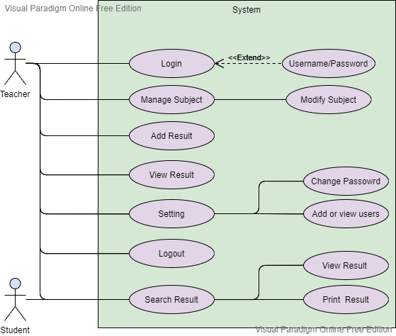

### 2.4.4 Activity Diagram

An activity diagram is a behavioral diagram i.e., it depicts the behavior of a system. An activity diagram portrays the control flow from a start point to a finish point showing the various decision paths that exist while the activity is being executed. They are graphical representations of workflows of stepwise activities and actions with support for choice, iteration and concurrency.

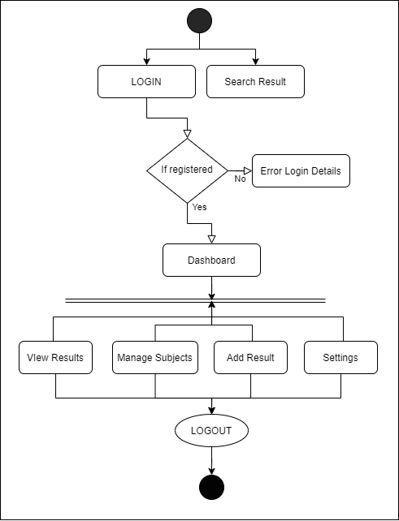

Figure 2.2: Project Activity Diagram

### 2.4.5 Work Flow Diagram

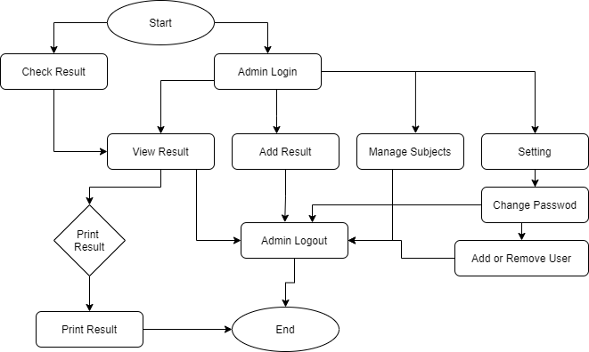

Figure 2.3: Project Activity Diagram

## 2.5 Implementation

All of the modules were implemented to put together the system at the end to be implemented in the real life. There were two main modules in this project; the ‘User’ module and the ‘admin’ module.

### 2.5.1 The User module

This module was responsible for dealing with all the actions related to the user itself. These include search of the result of the students according to their class along with their names. This module displays the record of the students without any credentials. Some screenshots highlighting the user module:

Figure 2.4: Home page

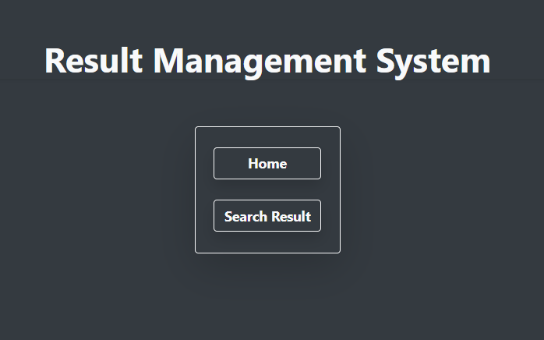

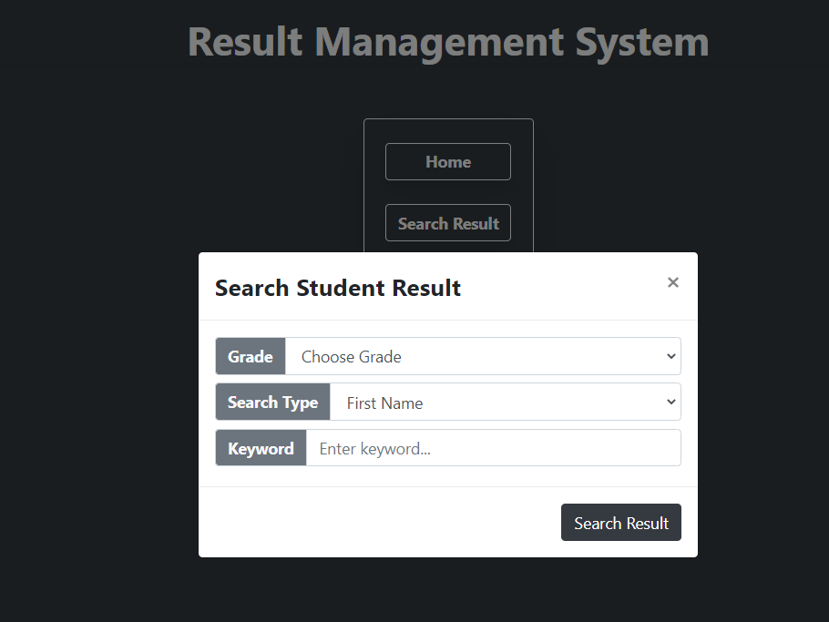

Figure 2.5: Search Record page

### 2.5.2 The Admin module

This module is responsible for handling the recording of all the students records. This module communicated directly with the database to insert new records, update previous records, and queries the database to find the required record.

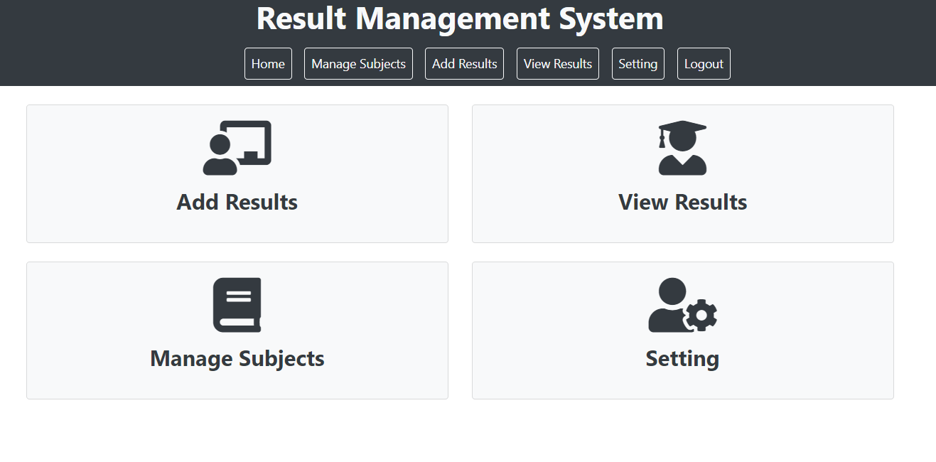

Figure 2.6: Dashboard

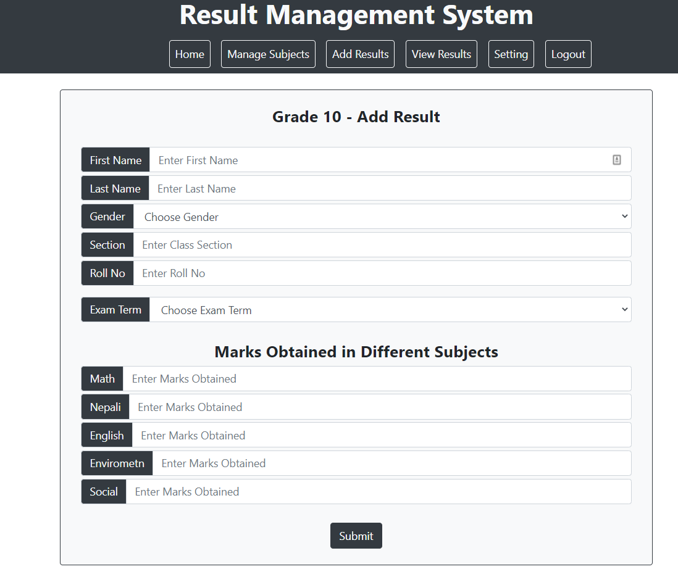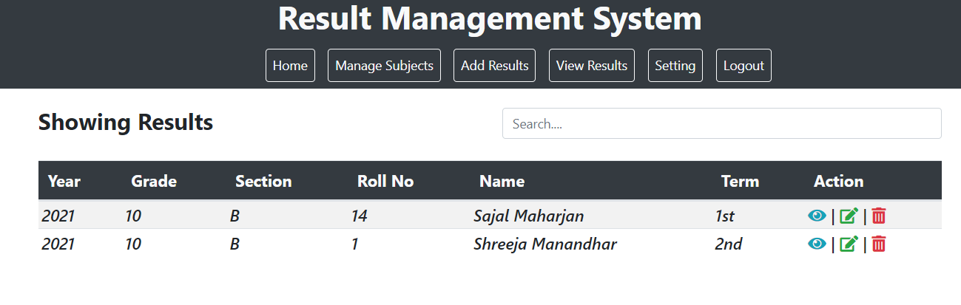

Figure 2.7: Adding of Record Page

Figure 2.9: Detail view of a record

Figure 2.8: View Result Page

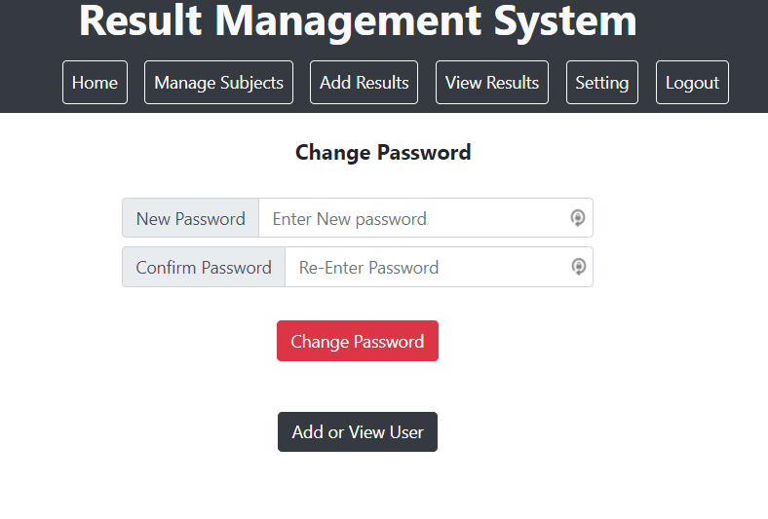Figure 2.9: Setting Page

## 2.6 System Testing and Validation

### 2.6.1 System Testing

System Testing is a level of the software testing where complete and integrated system is tested. The purpose of this test is to evaluate the system's compliance with the specified requirements. The application was tested during its development using a fair methodology with bugs being fixed as they were discovered. After each section of the application was completed, it was tested so that errors could be rectified.

### 2.6.2 Integration Testing

Integration testing involves testing the interfaces between programs. Integration testing was applied to this project by testing the integration between the database and the main application. Integration testing between the appointment component and database was also performed. Information needs to be read from the database and also inserted into the database by the main application for the system to work successfully as intended. To perform these tasks, INSERT and SELECT queries are executed by the main application. Using dummy data several tests were carried out to ensure data is being correctly entered into the appropriate fields and tables in the database and also retrieved from the database. Some problems were discovered using the method and was solved by adding validation code.

### 2.6.3 Validation Testing

In this testing, requirements established as part of system requirements analysis are validated against the system that has been constructed. Validation testing provides final assurance that system meets all functional, behavioral and performance requirements. Validation can be defined in many ways but a simple definition is that validation succeeds when system function in a manner that can be reasonably by the user.

### 2.6.3 Unit Testing

In unit testing, testing is performed module by module manually. Each individual unit of the system is tested with test data to ensure that it behaves as it is expected. The units of the system should be tested to ensure that the system provides the desired output. Valid and invalid data will be fed to the system to see how the system reacts. Testing will be done in terms of validation and corrective-ness of the data value. Unit testing is easier to find errors because instead of testing the whole system, we can test each individual unit will make it easier to spot errors and bugs.

|  |  |  |  |  |  |  |  |
| --- | --- | --- | --- | --- | --- | --- | --- |
| **TC_ID** | **Name** | **Prerequisite** | **Steps** | **Test Data** | **Expected output** | **Actual Output** | **Result** |
| TC_01 | Login | User should be on the Log page. | • Type username  • Enter the password • Enter email • Hit ‘Login’ | Username: Admin  Password: ‘admin' | User registered successfully! | User registered successfully! | Pass |
| TC_02 | Register | User should be on the Login page. | • Type username  • Enter the password • Enter email • Hit ‘Login’ | Username: Admin  Password: ‘Sajal' | Invalid Username or Password | Invalid Username or Password | Pass |
| TC_03 | Login | User should be on the Login page | • Type username  • Enter the password • Enter email • Hit ‘Login’ | Username: Admin  Password: ‘admin’ | Logged in successfully. | Logged in successfully | Pass |
| TC_04 | View Result | User should be on the search page. | •Chose grade  •Chose search type  •Enter Keyword | __ | Show the searched result | Show the searched result | Pass |

Table 2.10: Test Cases

## 2.7 Findings

After the implementation of the new system at the site, the overall record keeping process was found to be highly more efficient than before. All the records were digitized and the chances of losing valuable information was greatly reduced. The school got used to the new system pretty fast and was able to swiftly get around the UI. The traditional way of recording result has been replaced with the new digitized way. It was very quick to find a particular required record and its detail using the search and advanced search functions of the system. Overall, the efficiency of the school task has been boosted and resulted in almost zero cases of lost information.

# CHAPTER 3: DISCUSSIONS AND CONCLUSION

## 3.1 Discussion

This project’s main aim was to eliminate the manual recording of the student result of theschool and develop a computerized web-based system for the school in an organized and simple way. Being through different difficulties and overcoming those difficulties with the help from different persons and other different media this project has been successfully completed. Great effort and time were spent on completing the project as per the requirement specified by the organization.

Despite the challenges and problems, the project was completed in specified duration. The system was tested by the developers and by some other person indirectly involved in the project. The project is finally obtained as an online web-based system which has eliminate the manual data recording process of the school and helped to maintain a systematic record of information of all the students .

## 3.2 Conclusion

Despite the challenges and problems, the project was completed. After this project I have learned a lot of things and gained some new skills. For this project, the system was tested by the developers and by some other person indirectly involved in the project. The project is finally obtained as a system that can convert manual process into computerization of recording the expense and income information in an intuitive and easy-to-use system.

## 3.3 Further Enhancement

Although the project has been completed and able to overcome the problem of the study, there are still many tasks in the system to be enhanced in the future for better performance such as:

* More secure login system with 2 factor authentications
* Report of the classroom that includes all the students detail
* Storing data in a secured and encrypted way
* Making database strong so that no manipulation can be made from unauthorized access

# BIBILIOGRAPHY

* <https://getbootstrap.com/>
* <https://aceproject.org/ace-en/topics/vc/explore_topic_new>
* <https://www.webslesson.info/2020/12/online-student-result-management-system-in-php-with-mysql.html>
* <https://codecanyon.net/item/result-management-system/22462424>

# APPENDICES

## Interview Questions

* What is the name of your organization?
* How long has it been running?
* What type of services does it provide?
* How are you currently recording your records?
* What kind of software would you like?
* What are the needed features on the software?
* Who will be using this software?
* What type of device will this system be running on?
* Have you ever used a software like this earlier?